CSA1505-Cloud computing and big data analytics
4-Patient Progress
The Patient Progress Monitoring System in Zoho Creator helps healthcare providers track patient recovery and treatment progress. It stores patient records securely in the cloud, enables real-time updates, reduces paperwork, improves accuracy, and supports better decision-making through reports and progress tracking.
INPUT
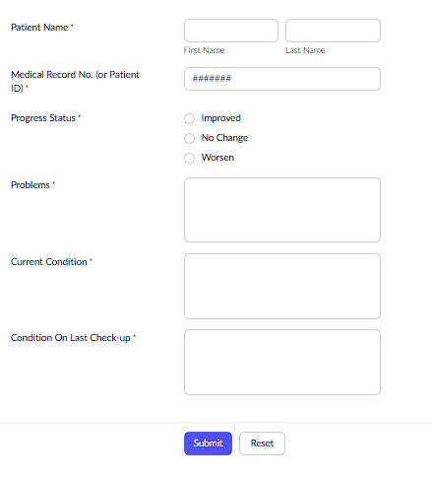

OUTPUT
